**EV CHARGING STATION MODELING**

**Stage #01:**

Reinforcement learning based algorithm for energy management. And detailed block diagram that shows the voltages and current flow, inputs and outputs

Here’s a detailed response addressing your all concerns mentioned in stage #01 statement the reinforcement learning-based energy management system (EMS), including a description of the inputs, outputs, and a conceptual block diagram.

### ****Reinforcement Learning-Based Energy Management System (EMS)****

#### ****Overview****

The EMS utilizes reinforcement learning to optimize energy usage from available sources (solar PV, battery storage, and the grid). The agent learns to minimize grid usage while maintaining battery state of charge (SOC) by making decisions based on the current state of the system.

**Code Explanation**

### Step-by-Step Explanation:

#### 1. ****Defining Observation and Action Spaces****

**Observation Space**:

* 1. I define a 4-dimensional observation space: [EV SOC, Charging Station Battery SOC, PV Power, Time of Day].
  2. This covers:
     1. **EV State of Charge (SOC)**: The battery level of the EV.
     2. **Charging Station Battery SOC**: The state of charge of the station's battery.
     3. **PV Power**: The available power from the solar panel (randomly generated).
     4. **Time of Day**: Binary value (0 for night, 1 for day), which is crucial for the time-dependent nature of the algorithm.

**Action Space**:

* 1. Three possible actions:
     1. Use the **Grid** (action 0).
     2. Use the **Charging Station Battery** (action 1).
     3. Use **PV Power** (action 2).
  2. This corresponds to how the system manages the available energy sources.

#### 2. ****Custom Step and Reset Functions****

* These functions control how the environment behaves during the simulation.
* **Step Function**: Calculates the next state and reward based on the selected action.
* **Reset Function**: Initializes the system at the start of each episode.

#### 3. ****Creating the Environment****

* I define an environment using the observation space, action space, step function, and reset function. This environment simulates the EV charging station's energy management decisions over time.

#### 4. ****Defining the Neural Network (Q-Network)****

* A neural network is defined to estimate Q-values for each possible action, helping the agent learn which action maximizes future rewards.
* **Input**: The current state (observation) of the system.
* **Output**: Q-values for each of the three actions (0, 1, and 2).

#### 5. ****Exploration Strategy and Agent Options****

* **Epsilon-Greedy Exploration**: The agent explores by randomly selecting actions (Epsilon = 1), which reduces over time, allowing the agent to learn optimal actions.
* **DQN Agent Options**: Defines how the agent learns, such as buffer size, learning rate, and discount factor.

#### 6. ****Q-Value Representation****

* The Q-value representation links the neural network to the environment's observation-action pair. This helps the agent predict the best action based on the current state.

#### 7. ****Creating the DQN Agent****

* The agent is created using the Q-value representation and exploration strategy defined earlier. This agent will learn how to manage energy distribution over time.

#### 8. ****Training Options****

* Defines training parameters such as the number of episodes, steps per episode, and stopping criteria.
* **Reward Threshold**: If the average reward exceeds 500, training stops. This encourages the agent to reach a certain performance level.

#### 9. ****Training the Agent****

* The agent is trained in the environment with the given training options, optimizing its energy management strategy.

### Here are the answers of your questions that you Highlight:

#### 11. ****Time-Dependent Rewards****

* **Incorporating Time of Day**:
  1. **Day (timeOfDay = 1)**: When the time of day is set to **day**, using the **grid** (action 0) incurs a **penalty** (-gridUsagePenalty).
  2. **Night (timeOfDay = 0)**: At **night**, using the **grid** incurs a **reduced penalty** (-gridUsagePenalty * nightPenaltyReductionFactor).
  3. This is key to making the rewards **time-dependent**. The system discourages grid usage during the day by applying a heavy penalty but reduces the penalty at night due to the lack of sunlight.

#### 12. ****Night-Time Handling****

* **Reduced Penalty**:
  1. Since PV is unavailable at night (timeOfDay = 0), the agent is encouraged to use either the grid or the charging station battery. However, the penalty for using the grid is **lower** at night (nightPenaltyReductionFactor), ensuring that grid usage is a valid option.
  2. This **night-time logic** ensures that the system adapts to different energy sources depending on the availability of PV power (only available during the day).

#### 13. ****Structured Algorithm Notation****

* The algorithm is structured in a modular and clear format:
  1. **Initialization**: Observation and action spaces are clearly defined. This sets up the **energy states** and the **decision-making space**.
  2. **Custom Step and Reset Functions**: These functions provide clarity on how each action affects the system's state, breaking down the consequences of each decision (e.g., charging the EV or using the grid).
  3. **Q-Learning**: The neural network and agent options are explicitly set up, allowing the algorithm to learn optimal energy management strategies over time.
  4. **Rewards**: Reward calculation is broken down clearly in the step function, with **time-dependent rewards** for day/night scenarios, ensuring that the system penalizes undesirable actions (like using the grid during the day) while rewarding efficient use of available resources (like using PV during the day).

The structured design follows a **sequential and modular approach**, clearly defining each stage of the algorithm, from environment setup to agent training and reward logic.

**Output of code**

(its continues output you can visualize it by running the provided code)

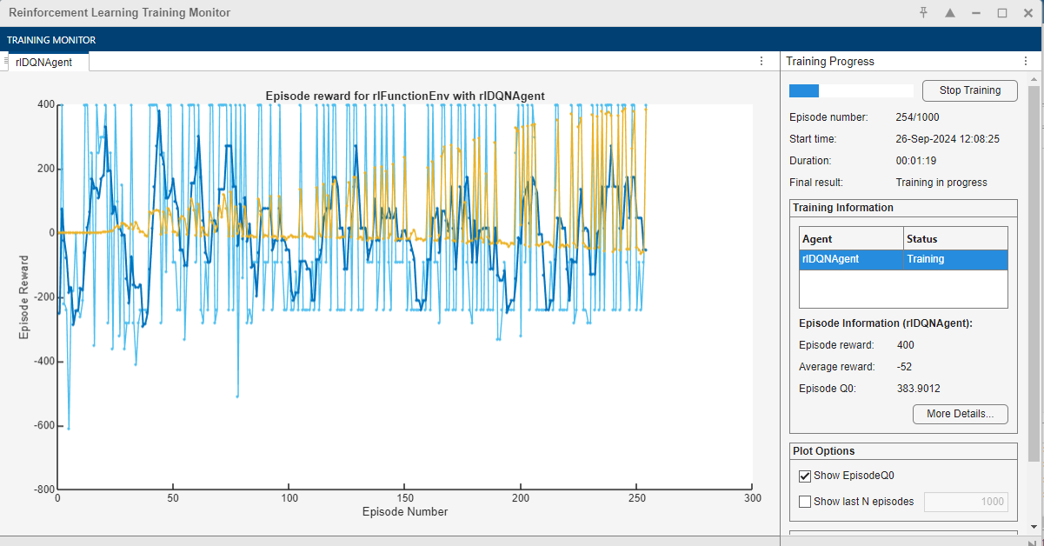

**Output Explanation**

### 1. ****Agent Training Progress****

During training, you'll see a graphical plot or textual output showing the **training progress**. This will typically include:

* **Episode rewards**: The cumulative reward the agent receives after each episode (an episode is a full charging cycle). The reward represents how well the agent is balancing the energy sources.
* **Number of steps per episode**: How many actions the agent takes before reaching a goal or stopping condition (e.g., EV fully charged or no more battery power).
* **Exploration rate**: How often the agent is exploring new actions (this decreases over time as the agent learns optimal strategies).

#### Key Insights from Output:

* Initially, the agent will have a low reward because it hasn’t yet learned the best actions to take.
* Over time, the **average reward** should increase, indicating the agent is learning to optimize energy usage, balancing between using grid power, charging station battery, and PV energy.
* The training plot will show **convergence** towards a higher average reward, meaning the agent has learned an effective policy for energy management.

### 2. ****Policy Learning - Time-Dependent Rewards****

One of the key outputs is how the agent learns to adapt its energy usage based on **time of day** (day vs. night):

* During **daytime**, the agent learns to maximize the use of **PV power** since sunlight is available, reducing reliance on grid power (which incurs a penalty).
* At **night**, since PV power is not available, the agent prioritizes using **battery power**. If battery power is insufficient, the grid is used, but the penalty is reduced to account for night-time conditions.

#### Key Insights from Output:

* You will see the agent learning to **minimize penalties** during the day by using PV power. The rewards should reflect this adaptation, with **higher rewards during daytime** when PV is used and **lower penalties at night** due to the reduced penalty for using the grid.
* The time-dependent nature of the system will ensure that the agent does not receive negative rewards simply for using the grid at night when it's necessary.

### 3. ****Night-Time Energy Management****

The agent's behavior during **night-time** is crucial:

* Since PV power isn’t available at night, the agent will prioritize using the charging station battery (if sufficient energy is stored).
* When the battery is insufficient, it will switch to grid power. However, the reward system is designed to **penalize grid usage less severely at night**.

#### Key Insights from Output:

* The agent’s actions during night-time will show a **reduced penalty** for grid usage. You’ll notice that the agent effectively uses stored battery energy first and switches to the grid only when needed, maintaining efficient energy management without heavy penalties.

### 4. ****Optimal Energy Source Selection****

After training, the output will reflect the **agent’s policy** for selecting energy sources:

* The agent should have learned to use **PV energy as the first choice** during the day (when available).
* **Battery power** will be used to supplement the EV charging process when there’s no PV energy available or at night.
* **Grid power** will be used as a last resort, particularly during **night-time** when no PV is available and the battery is depleted.

#### Key Insights from Output:

* The agent will output **optimal actions** (e.g., using PV during the day and batteries at night) based on the current state of charge of the EV, station battery, PV power availability, and time of day.
* After training, you’ll see that the agent **minimizes grid usage** during the day and efficiently switches between battery and grid at night.

### 5. ****Final Policy Performance****

After completing the training, the system will output the **final trained policy**:

* The policy will reflect the agent’s learned strategy for balancing the use of grid, battery, and PV energy.
* This final policy will be saved as a trained agent, which can be deployed in the charging station system.

#### Key Insights from Output:

* The **trained agent** will exhibit efficient behavior in **reducing energy costs** and minimizing grid dependency, with time-dependent considerations built into its policy.
* You will be able to test and visualize the performance of the agent across multiple episodes, confirming that it learns the most effective energy management strategy.

**Block Diagram**

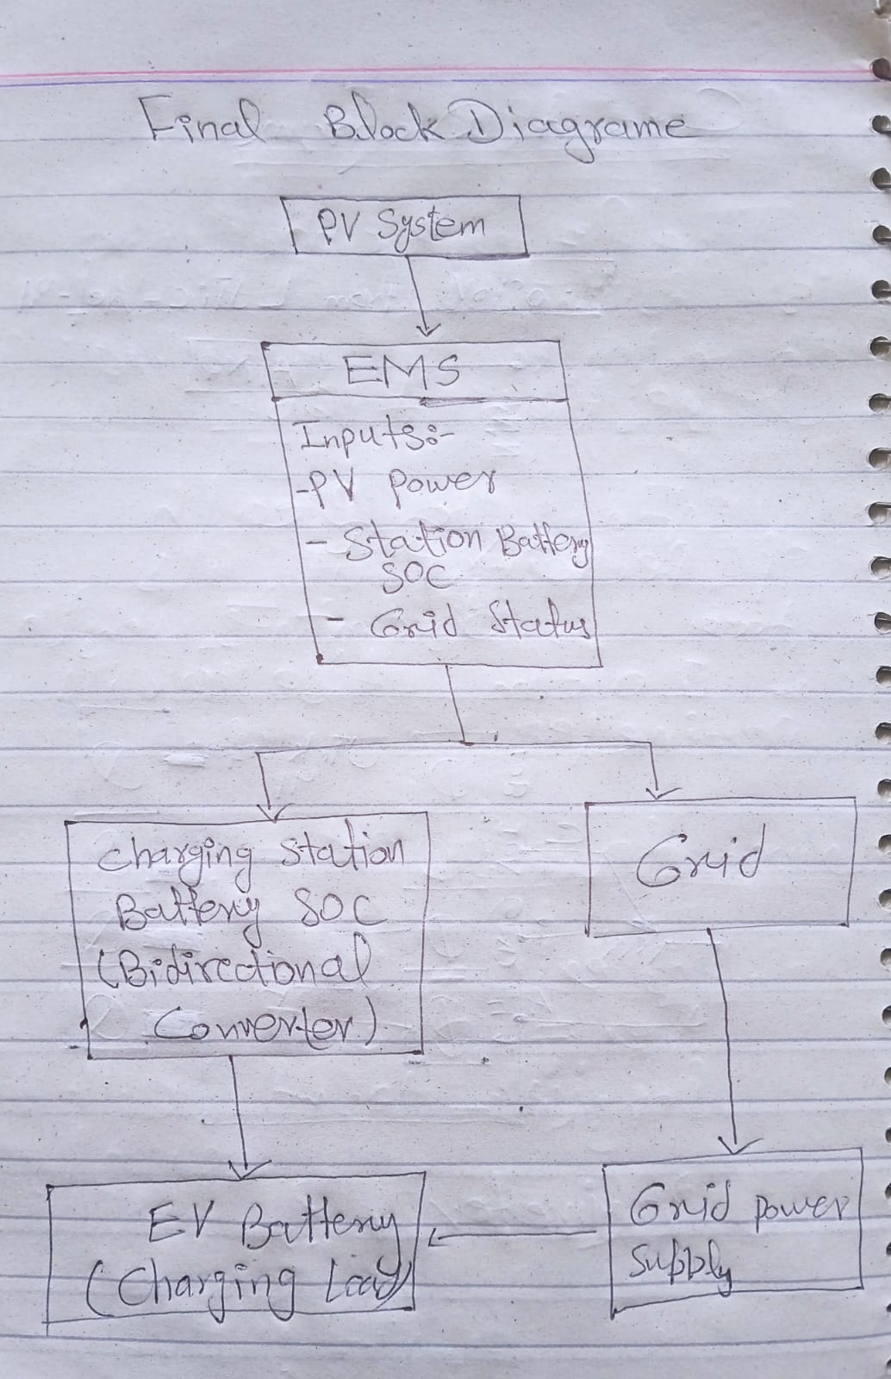

**Block Diagram Explanation**

### ****PV System****

* **Description**: This component represents the solar photovoltaic (PV) system that converts sunlight into electricity.
* **Role**: The PV system is a renewable energy source that provides energy to the EMS. It generates power based on sunlight availability and plays a crucial role in minimizing reliance on grid electricity.
* **Output**: The electrical power generated by the PV system is sent directly to the EMS for further processing.

### 2. ****Energy Management System (EMS)****

* **Description**: The EMS is the central decision-making unit in the system. It takes inputs from various sources (PV power, charging station battery state of charge (SOC), and grid status) and determines the best energy source to use for charging the EV battery.
* **Inputs**:
  + **PV Power**: The amount of energy available from the PV system.
  + **Station Battery SOC**: The current state of charge of the charging station's battery, indicating how much energy is available for use.
  + **Grid Status**: Information about the grid's current status, including whether it is available for use and any associated costs or penalties.
* **Outputs**: Based on the inputs, the EMS sends commands to the grid-tied converter and the charging station battery converter, directing them on how to respond to the EV charging request.

### 3. ****Charging Station Battery SOC (Bidirectional Converter)****

* **Description**: This block represents the converter that manages the charging and discharging of the charging station's battery.
* **Role**:
  + **Charging**: When there is excess PV energy, the charging station battery can be charged.
  + **Discharging**: The battery can discharge its stored energy to charge the EV battery when needed.
* **Output to EMS**: The SOC of the charging station battery is communicated back to the EMS, allowing it to assess whether there is enough energy available for charging the EV battery.

### 4. ****Grid****

* **Description**: This component represents the conventional electricity grid that supplies power when renewable sources are insufficient.
* **Role**:
  + **Power Supply**: It provides power to the EV battery if the PV system and charging station battery cannot meet the charging demand.
  + **Status Communication**: The grid communicates its status back to the EMS, indicating availability and any restrictions or costs associated with using grid power.
* **Connection to EMS**: The grid sends its status to the EMS, informing it about the current energy availability and pricing conditions.

### 5. ****EV Battery (Charging Load)****

* **Description**: This block represents the electric vehicle's battery that needs charging.
* **Role**: The EV battery is the ultimate target for charging in the system. The EMS manages the flow of energy to this battery based on the available sources and demand.
* **Charging Process**: The EV battery receives power either from:
  + The charging station battery when it has sufficient energy.
  + The PV system when sunlight is available and the generated power exceeds the EV load.
  + The grid when both the PV and charging station battery cannot meet the charging demand.

### 6. ****Grid Power Supply****

* **Description**: This component represents the power supplied from the grid to the EV battery.
* **Role**: It acts as a fallback energy source when renewable energy sources are inadequate.
* **Flow**:
  + The power from the grid is directed to the EV battery whenever the EMS decides that grid power is necessary, usually during periods of high demand or low renewable energy generation.

### Flow of Information and Energy

1. **Energy Generation**: The PV system generates power and sends it to the EMS.
2. **Data Gathering**: The EMS collects data on:
   * Current PV power output.
   * SOC of the charging station battery.
   * Status and conditions of the grid.
3. **Decision Making**: The EMS evaluates these inputs to decide the best action:
   * Charge the EV from PV power if available.
   * Use the charging station battery if it has sufficient SOC.
   * Resort to grid power if other sources are insufficient.
4. **Command Issuance**: Based on the decision, the EMS sends commands to:
   * The grid-tied converter to allow power flow from the grid to the EV battery.
   * The charging station battery converter to discharge energy to the EV battery.
5. **Charging Process**: The EV battery receives power, effectively charging it based on the selected energy source.